**NETWORKING&SYSTEM ADMINISTRATION LAB**

**Experiment No.: 21**

**Aim**

Docker installation on Ubuntu.

**Procedure**

**1.** Open the terminal on Ubuntu.

**2.** Remove any Docker files that are running in the system, using the following command.

After entering the above command, you will need to enter the password of the root and press enter.

**Command:** $ sudo apt-get remove docker docker-engine docker.io

Output:

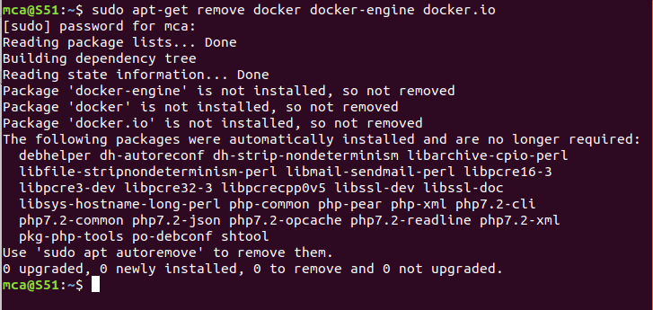

**3.** Check if the system is up-to-date using the following command.

**Command:** $ sudo apt-get update

Output:

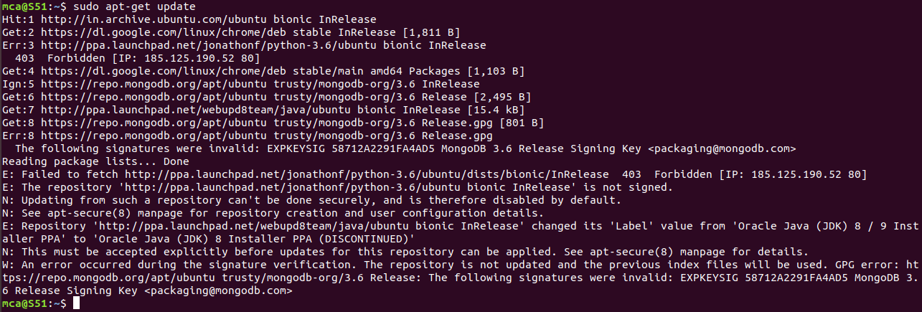

4. Install Docker using the following command.

You’ll then get a prompt asking you to choose between y/n – choose y

Command: $ sudo apt install docker.io

Output:

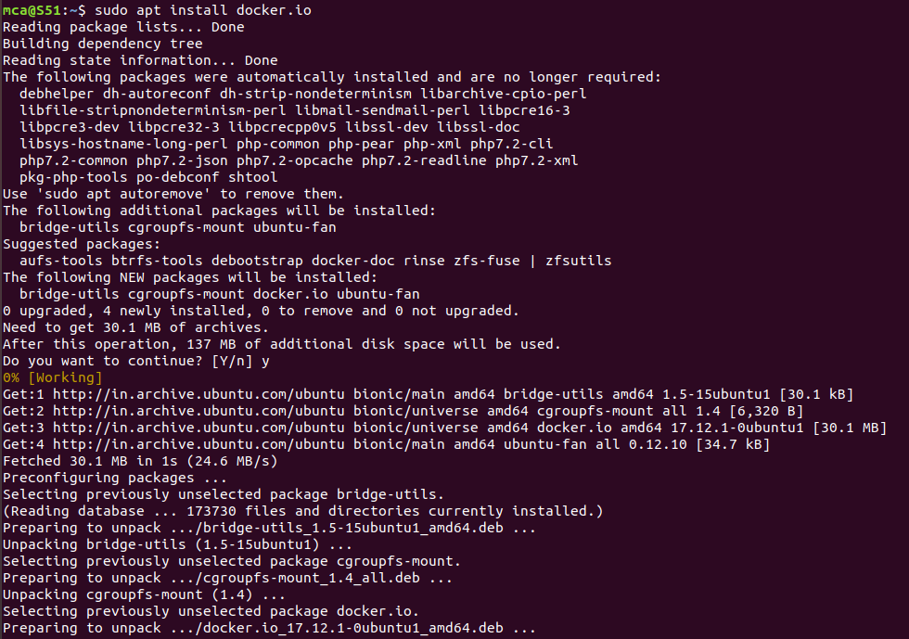

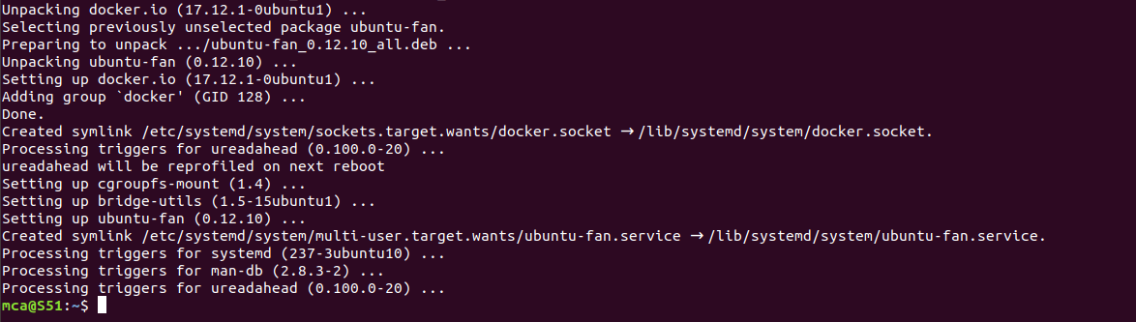

**5.** Install all the dependency packages using the following command.

**Command:** $ sudo snap install docker

Output:



**6.** Before testing Docker, check the version installed using the following command.

**Command:** $ docker --version

**Output:**



**7.** Pull an image from the Docker hub using the following command:

Here, hello-world is the docker image present on the Docker hub.

**Command:** $ sudo docker run hello-world

Output:

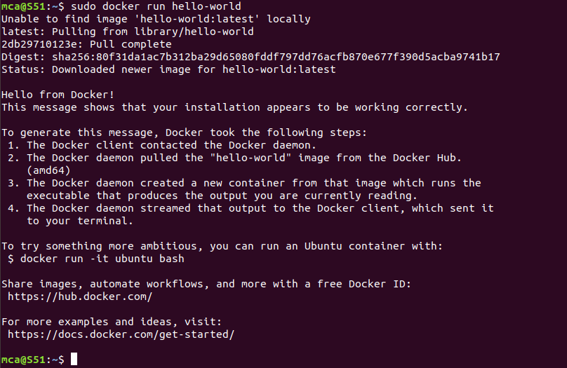

8. Check if the docker image has been pulled and is present in your system using the following command.

Command: $ sudo docker images

Output:



9. To display all the containers pulled, use the following command:

Command: $ sudo docker ps -a

Output:



10. To check for containers in a running state, use the following command.

Command: $ sudo docker ps

Output:



You’ve just successfully installed Docker on Ubuntu.

